Russian Federation: Recent Economic Developments and Outlook

# GDP growth in 2019 increased

GDP growth increased by 1.3% year-on-year (yoy) in 2019. On the demand side, private consumption (50.4% of GDP) contributed the most to growth, with 1.3 percentage points (pp). On the supply side, services (54.0% of GDP) contributed the most to growth, with 0.9pp.

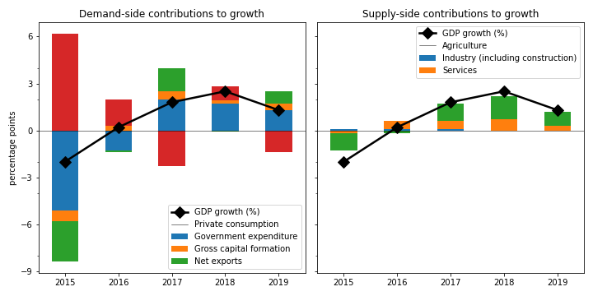

## Gross capital formation jumped the fastest on the demand side

Gross capital formation jumped by the largest margin (3.8%). Private consumption expanded by 2.5%. Government expenditure jumped by 2.2%. On the other hand, net exports contracted by 22.3%.

## On the supply side, services grew the fastest

Services grew the most rapidly (1.6%). Industry (including construction) picked up by 1.0%. Agriculture grew by 0.6%.

## Unemployment declined; inflation increased

Unemployment declined from 4.8% in 2018 to 4.5% in 2019, while inflation increased from 2.9% to 4.5%. At the end of 2020, the central bank set the policy rate at 4.3%.

## Current account balance surplus

The current account balance (CAB) recorded a surplus at 3.8% of GDP in 2019, compared to 6.9% in 2018.

China is the top export destination (13.4% of exports in 2019). Other major exports partners include Netherlands (10.5%), Germany (6.6%), and Belarus (5.1%). Top export products are mineral fuels, mineral oils and products of their distillation; bituminous substances; mineral waxes (52.0% of exports).

Top imports origins are China (21.9%), Germany (10.2%), Belarus (5.5%), and USA (5.4%). Major import commodities are nuclear reactors, boilers, machinery and mechanical appliances; parts thereof(17.5% of imports).

# Output contracted in Q3 2020

Output plunged by 3.0% yoy in Q3 2020 (-5.0% in the previous quarter). Household consumption contracted by the largest margin at -16.4% yoy. Exports contracted by 9.5%.

## Leading indicators

Consumer confidence index was in the negative territory at -25.2 in Q4 (-23.1 in Q3). Retail sales shrank by 3.8% yoy in December (-1.2% yoy in November). Industrial production shrank by 0.8% yoy in December (-5.9% yoy in November).

## Inflation picked up

Inflation rose to 4.9% yoy in December (4.4% yoy in November). Meanwhile, the central bank kept the policy rate to 4.3% in January.

# Outlook favorable this year

As of January 2021, Consensus Economics panelists project economic growth ending at 2.8% in 2021, while in 2022, the panelists foresee growth at 2.7%. Over the same period, consumption is expected to change by 3.8% and 3.2%, while investment is projected to change by 4.2% and 4.0%. Industrial production is seen to change by 3.2% and 3.9%. Finally, Consensus Economics foresee inflation at 3.7% in 2021 and 3.9% in 2022.

*Sources: Consensus Economics, The World Bank, UN Comtrade, Haver Analytics, and National Sources. Accessed 06 February 2021.*